

Hydromet Tools User Manual

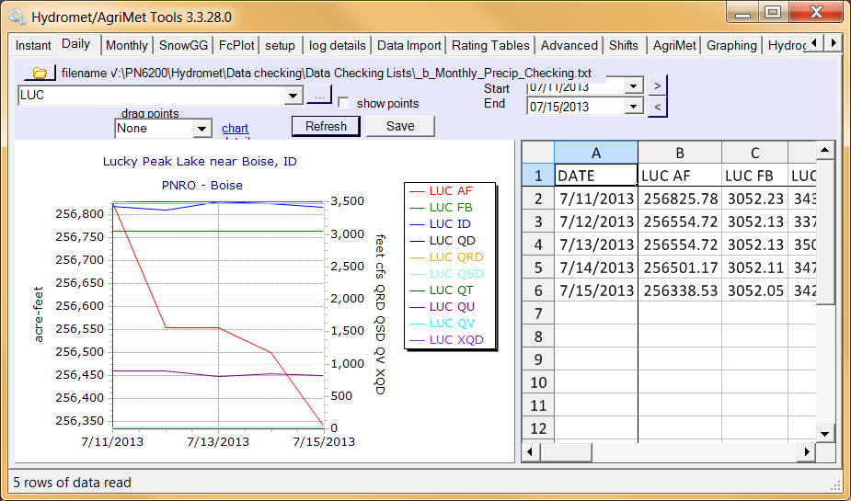

Mission Statements

The mission of the Department of the Interior is to protect and provide access to our Nation’s natural and cultural heritage and honor our trust responsibilities to Indian Tribes and our commitments to island communities.

The mission of the Bureau of Reclamation is to manage, develop, and protect water and related resources in an environmentally and economically sound manner in the interest of the American public.

Contents
Introduction 1
Installation 1
Querying Data 2
Querying Hydromet data using a pre defined file list 3
Instant Data 4
Daily Data 8
Monthly Data 8
Data Checking 8
Snow GG 8
Setup 9
Log Details 9
Data Import 10
Rating Tables 11
Advanced 13
Help 13
Agrimet 15
Graphing 15
Hydrograph Editor 15

Introduction
Hydromet Tools is a desktop application that allows you to graph and edit series data such as gauge height, river flow, water temperature, etc.

Installation
Requirements:
- Windows- XP or higher
- .net 2.0 or higher

Download Hydromet Tools from:
http://www.usbr.gov/pn/hydromet/hydromettools-setup.exe

Hydromet Tools installation does not require any special user privileges, so you will probably be able to install this yourself. If not, contact your administrator.

Querying Data

Hydromet data is queried using a CBTT and parameter code like this: ‘JCK FB’ The CBTT is the short name for a Hydromet site, such as JCK (Jackson Lake). The CBTT tells where the data is coming from. The parameter code, such as FB (forebay), tells what type of data you want.

For example enter the query JCK FB as shown below and click the Refresh button.
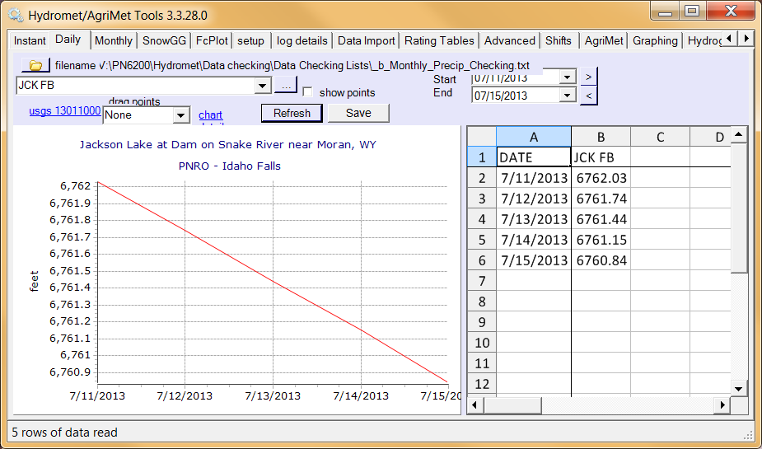
This forebay data is graphed on the left, and tabulated on the right.
More query example.
Example | Description
JCK FB | Jackson Lake forebay
JCK FB,AF | Jackson Lake forebay and storage (acre-feet)
JCK | Jackson Lake. All parameters are plotted because only the CBTT is entered.

The first three tabs in Hydromet Tools: Instant, Daily, or Monthly determine the interval of data. Some parameter codes are different between intervals. For example flow rate is ‘Q’ for instant and ‘QD’ for daily.

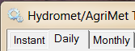

It is possible to mix intervals in a single graph so you can graph daily data and instant data in the same graph. Or you could graph monthly data mixed with daily. However, the table will only show and allow editing for the interval/tab selected. To mix intervals put a prefix in front of the cbtt. For example, enter ‘jck af, d:jck af’. This query means graph Jackson contents in whatever interval you have selected, and also plot the daily Jackson contents.

Prefix | Description
d: | daily data
i: | instant data
m: | monthly data

Querying Hydromet data using a pre defined file list
Note that there is a set of data called “Data Checking” that will be used for Hydromet/Agrimet data checking.

To use Hydromet Tools for the first time, you must import a set of time-series data. In order to Navigate to “Data Checking” use the following /PN6200/Hydromet/Data/Hydromet data checking lists

Left click on a file name on the left hand side of the screen to import your data into Hydromet Tools.
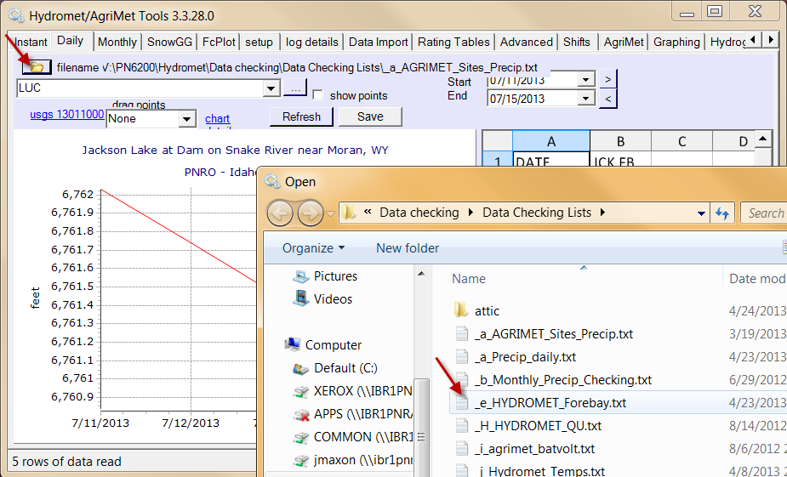

Instant Data
Most of the instant Data is data received via satellite every 15 minutes.
After reading data, you can observe the graphed data on the left and edit the data on the right. 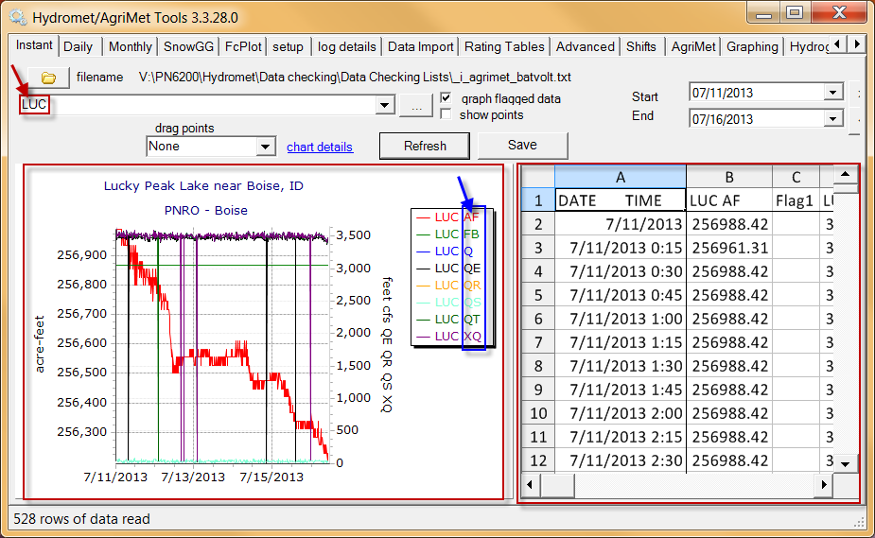

All data is queried through two types of codes, CBTT and PCODE. Such as LUC(Lucky Peak) and FB(Forebay)
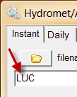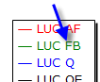

Hydromet Tools also has the ability to graph multiple CBTT and PCODES at once. This graphing technique can save a lot of time. You can see on the graph below under the filename box there is a single CBTT code followed by two PCODES, and this process is repeated multiple times.

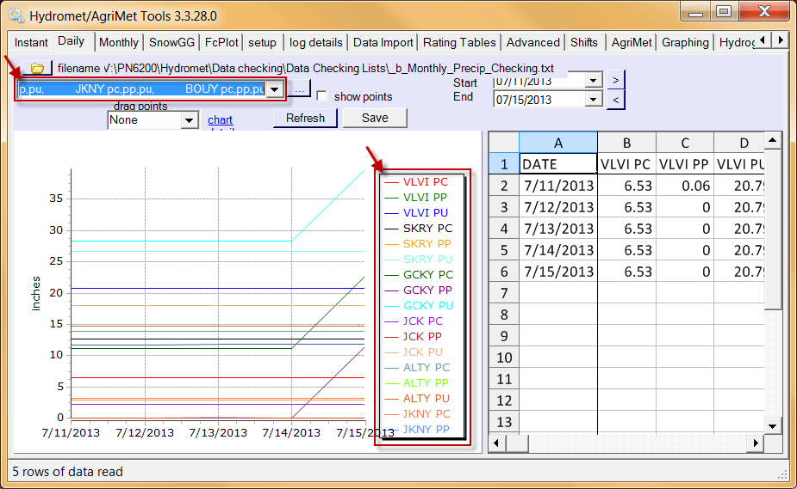

The range at which you view this data can be changed using the Start and End Dates.

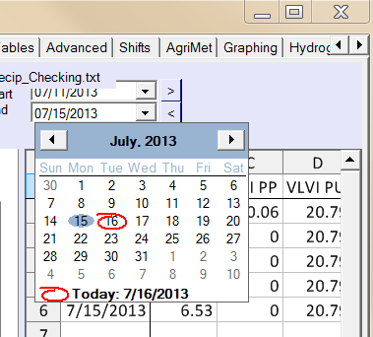

Graphing flagged data means data that is outside the acceptable ranges still gets graphed.
Show points shows data points on your graph.

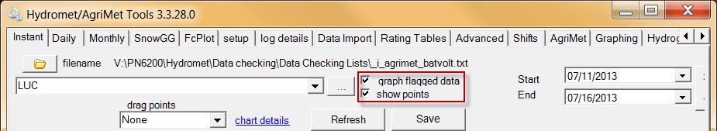

For example: This is the same graph as above but with one flagged data point at 11/10/2011 0:15 and the actual data points displayed on the graph.

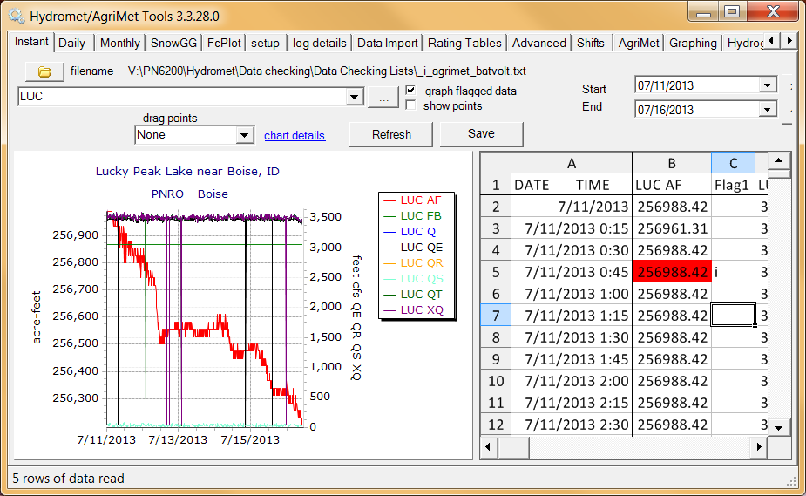
When modifying instant data you have an option to apply rating table math(which is currently grayed out but has a red arrow indicating where it is.) and/or compute daily values. The rating table math computes storage (AF) based on forebay (fb) or computes flow (Q) based on gage height.
When modifying Instant data for Agrimet you have three extra options available ET, Crop Charts and Send to Web. When the ET box is checked Hydromet tools will use new/edited data to recalculate the evapotranspiration (ET). This will only have effect if you edit data that is used to calculate ET.
Check the compute daily values checkbox to compute daily data based on the edited instant data.
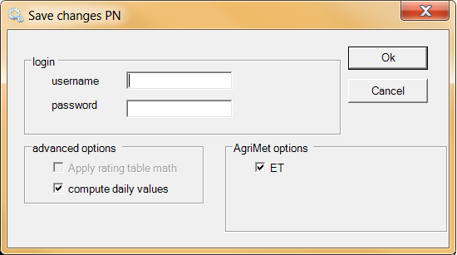

Daily Data
Daily data is retrieved the same way instant data is. Daily data is very similar to instant data except it’s the daily values graphed instead of 15 minute intervals. Most of the daily data is calculated using the instant data. Other daily data is manually entered.

Old timers often call the daily data ‘archives’.

Monthly Data
Monthly data is retrieved just like instant and daily data. Monthly data again is very similar to daily and instant data, except its monthly data that is graphed here. Some monthly data is calculated with the daily data and a significant amount is hand entered by the forecasters

Old timers call the monthly database ‘MPOLL”

Data Checking
Data checking is a process that uses specific lists created to compare received data for irregularities or faults. Some of these lists include: Agrimet_Sites_Precip.txt, Monthly_Precip_Checking, Hydromet_Forebay to name a few.

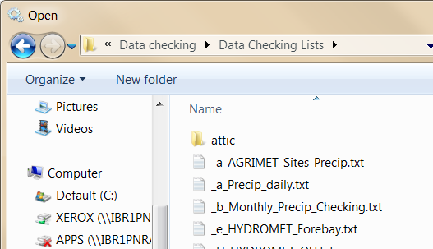

Precipitation Editing
Precip directory: V:\PN6200\Hydromet\Data checking\Data Checking Lists
Precip editing is done by bringing in three Daily parameters associated with the same CBTT (graph below). Boii pc, pp, pu
PC = Precipitation, Cumulative (Inches)
PP = Precipitation, Daily total (Inches)
PU=Cumulative Water Year Precipitation (Oct 1 to Date (Inches).
An easier way to look at these three parameters is:
PC=How much fluid in bucket (in real world/real time).
PP=How much fluid +/- occurred that day(rain/evaporation).
PU=How much it has rained this water year at this particular site.
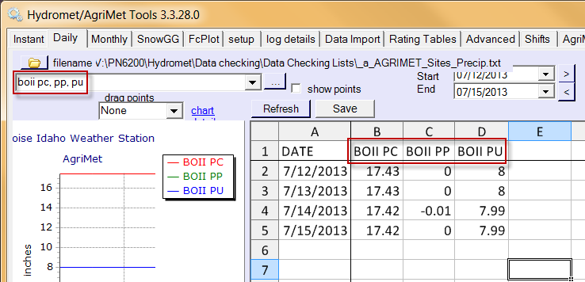

One of the easiest ways to recognize that there may be a precip edit needed is looking for negative values. You can easily see the negative value in this above example with (-0.01) on 7/14/2013. When editing precipitation it is important to always compare the daily computed values to the instant data. The instant data can often times take a bit of finesse to interpret. Below is a graph of the instant data for the same period of time as the Daily data in the above graph. Observe the data below as it jumps around between 17.44 and 17.41 (0.03 inches). This is a great example of what we call precip flutter. Precip flutter can be cause by temperature, metal shielding touching the bucket, high winds. The PP from the above graph shows a (-0.01) on the 14th, you can see by this graph of instant data that the precip has not really changed over this period of time its simply fluttering. The PP is actually calculated by midnight values and depending on where this flutter is at that time HydroMet will calculate a possible negative or even positive value. Both of these possible outcomes would be incorrect, the actual PP for the 14th is zero (0). It’s up to the data checker to interpret how much precip is actually here. There are four possible PC interpretations from this graph, two of which are more reasonable 17.43 and 17.42. Either of these values would be a good choice. The important thing is to keep it consistent until a precip event or possible evaporation.
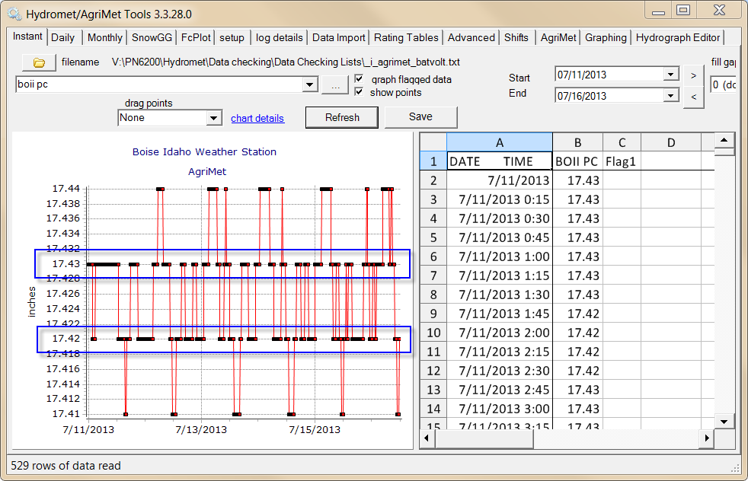

Editing The Daily Values
Once you have determined that the negative value was caused by a calculation at a specific time and not actual evaporation you then leave the instant data as it is and return to the Daily tab. On the Daily tab you simply zero that negative out. With the negative zeroed out you can then self calculate what the PC and PU should be. Simply add (0.01) to both PC and PU and then save your changes. Once saved the aforementioned Daily graph should look like the graph below.

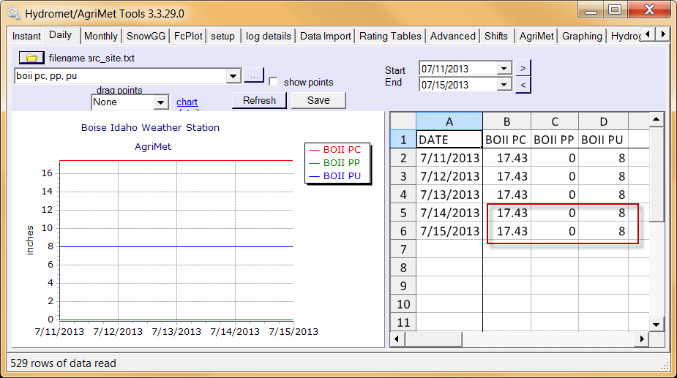
Editing Forebay values
Forebay directory: V:\PN6200\Hydromet\Data checking\Data Checking Lists
When doing forebay data checking it’s important to remember that some reservoirs have key characteristics that make them different form the rest. Most of the time when checking forebay levels there won’t be anything significant. Often times there are situations like below. The below graph shows frequent FB “dropouts” There are several reasons why dropouts happen. You’ll notice the “graph flagged data” box is checked so you can see these dropouts. Below this graph is the exact same graph with the box unchecked.

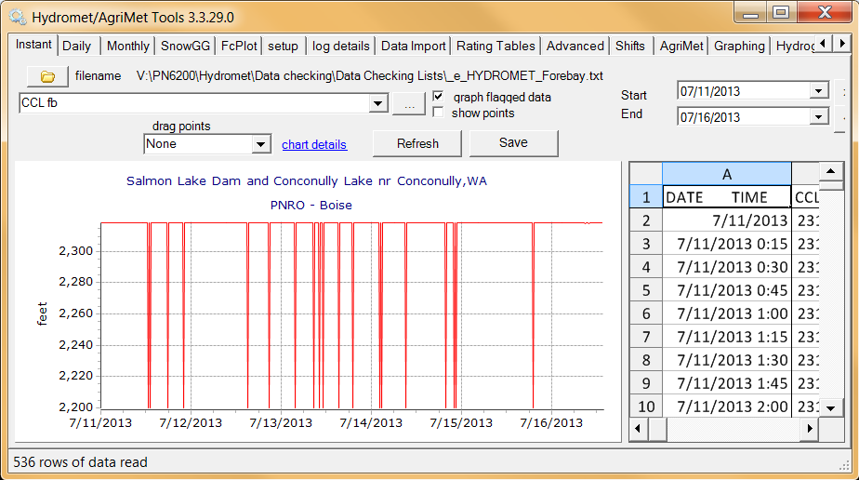
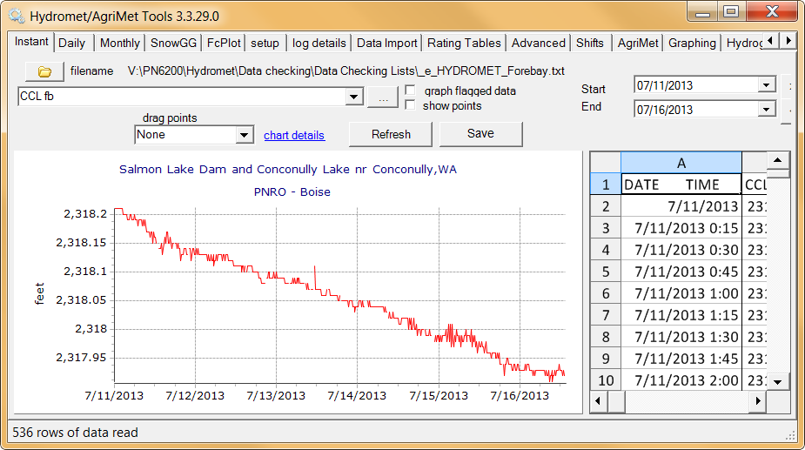
When un-checking this box you will see what the data looks like without the “dropouts”. This is a normal occurrence in some sensors and isn’t necessarily a problem.
Another problem you may encounter when checking FB elevations is a decrease in nitrogen pressure. These types of sensors require constant nitrogen pressure in order to correctly measure the Forebay. When a nitrogen bottle is running close to empty you may notice a graph similar to Lake Waha below.
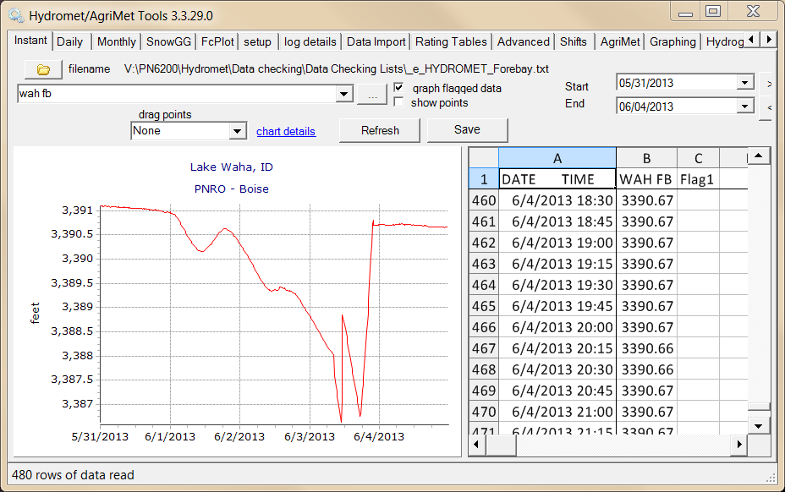

Often times there isn’t any editing needed for forebay values until after the issue has been corrected. Once issues are correct (nitrogen bottle replaced or what have you) the data can then be corrected. These types of edits will often times be sent to you.

Rivers and Reservoirs
When looking through the rivers and streams or “Water ways” you’ll be looking for anything out of the ordinary. This takes time to get used to but basically you are looking for huge differences in a relatively small amount of time. This same technique can be applied to reservoirs.

AgriMet Data Checking

AgriMet data checking is performed by using an exel spreadsheet that will load all Agrimet sites current data in the last few days.

Snow GG
Snow GG is used to graph multiple water years of daily data.
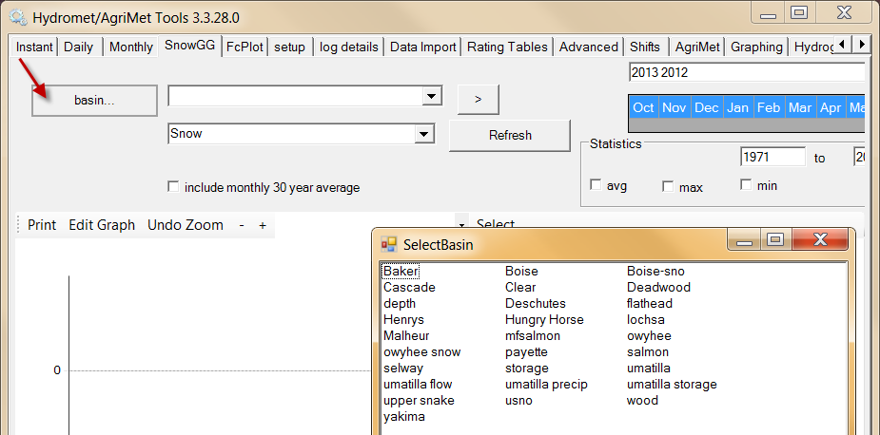

Setup
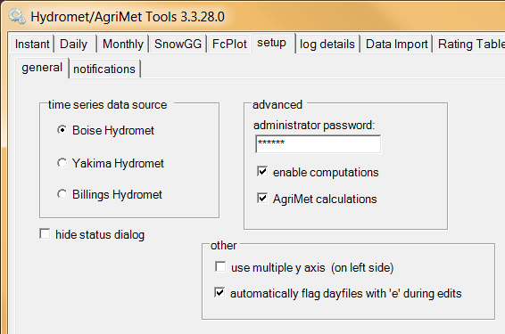

Log Details
Log details is useful for debugging. When something doesn’t seem right you can look here for technical details.

Data Import
Use the Data import Tab to import published data from USGS, NRCS and Idaho power. The published data is compared to Hydromet data. For example this Summit Lake OR, graph compares data between Hydromet and NRCS on the top graph and the difference between NRCS’s data and Hydromet data on the bottom. Again these are organized by CBTT and PCODE.
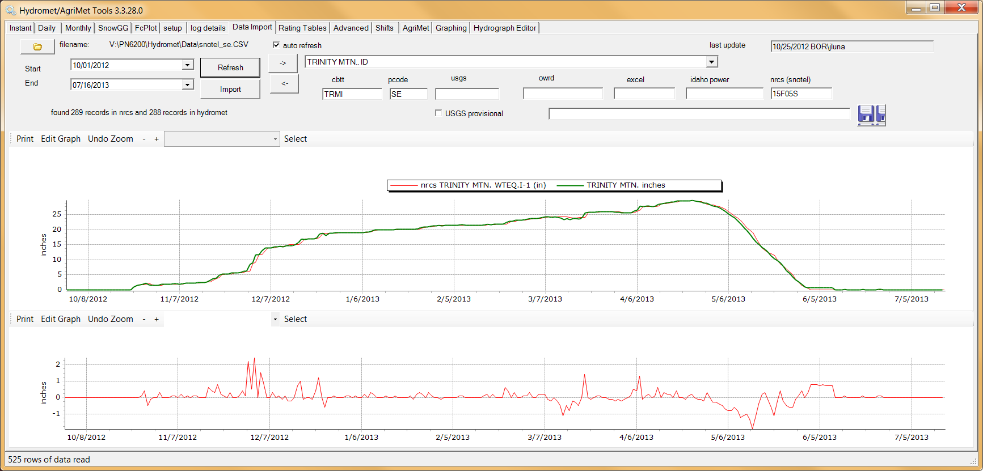
USGS

OWRD
http://apps.wrd.state.or.us/apps/sw/hydro_near_real_time/default.aspx

Excel

Idaho Power

NRCS (Snowtel)

Rating Tables
The rating tables tabl allows viewing the expanded version of rating tables. (Waring: CURRENTLY is this for the Boise server only)
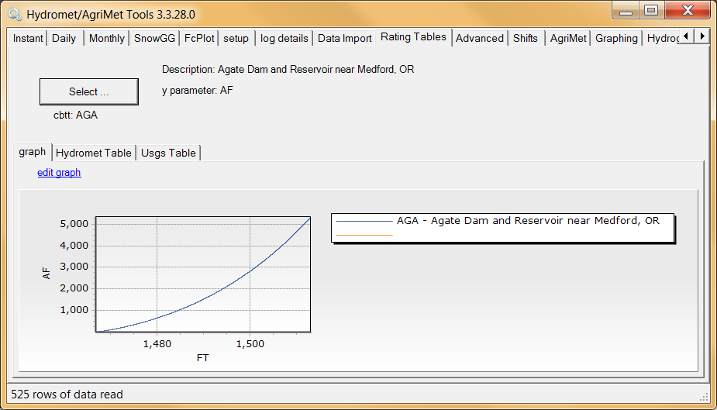

Selecting Rating Table

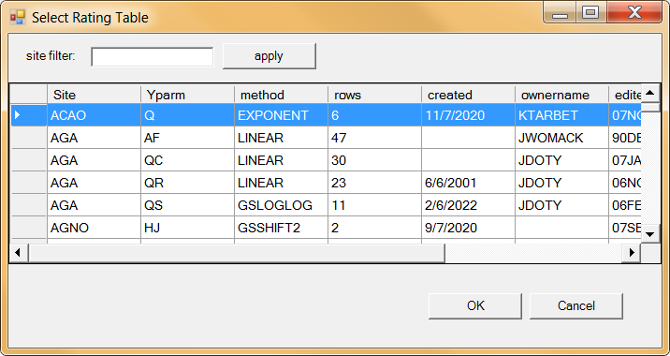

Advanced
The advanced tab only appears if you enter the administrator password. Call the Hydromet manager if you need this password (208) 378-5272.

Raw data can be usefull…

Daily calculations

Rating table calculation

Insert zeros.
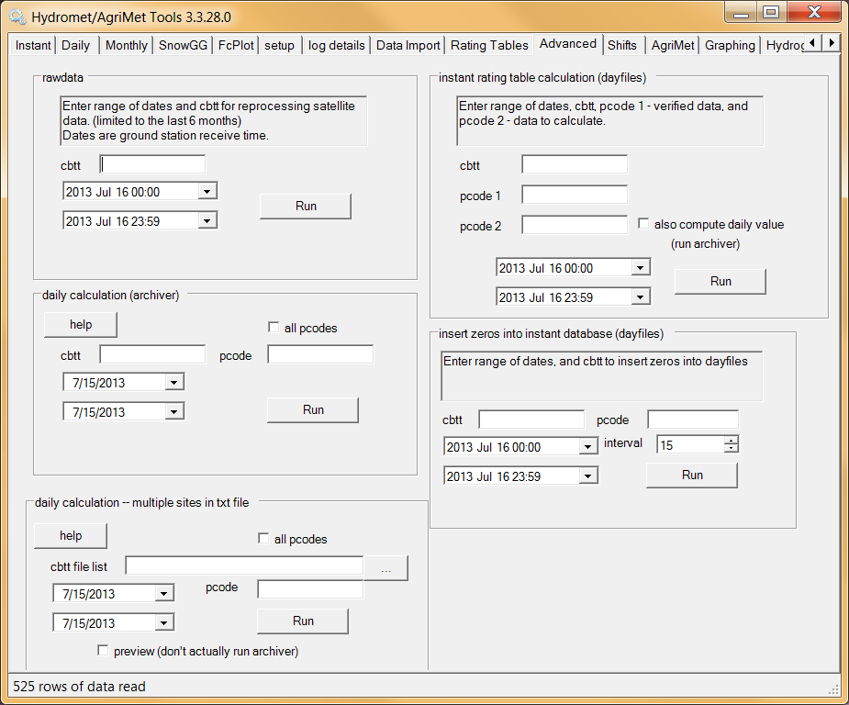

Help
FAQ
What do I do if the program is not responsive?
- Usually this means your password was typed incorrectly or your password may have expired.
- Close the program using the task manager and select “end task”.
- Use a terminal emulator to verify or change your password.
$ set password
Old password: ******
New password:XXXXX
Verification:XXXXX

Why is it so slow when I paste tons of data into Hydromet tools?

If you are pasting lots of data use the context menu (right click Paste.)This is much faster than using Control-V key shortcut.

I don’t know what all of these PCODES represent, how can I look them up?

In the directory where Hydromet tools is installed (usually C:\HydrometTools) open the file named Pcode.csv. It looks like this:
ALTY OB | Air Temperature - Deg. F
ALTY PC | PRECIP, CUMULATIVE (INCHES OF WATER) (30" BELFORT)
AMF AF | Reservoir Storage - Acre-Feet
AMF FB | Forebay Elevation - Feet
AMF OB | Air Temperature - Deg. F
AMF PC | PRECIP, CUMULATIVE (INCHES OF WATER) (12" Belfort)
AMF Q | Discharge - CFS
AMF TP | AIR TEMP, DEW POINT (DEG F)
AMFI GH | Gauge Height - Feet
AMFI OB | Air Temperature - Deg. F
AMFI Q | Discharge - CFS
AMFI WF | Water Temperature - Deg. F

-For the most up to date pcode data use SmarTerm to look this up. Log into SmarTerm and type in “MCF” at the prompt ($). From the MCF Main Menu select “E” (Enter/Edit site definition). Once at the “Master Site Definition” area type in the Site you which to view i.e. ABEI then press return. Now you’ll see all of the PCODES near the bottom right of the screen, in order to access these you’ll need to select PF2(Edit parameters) or the “/” key on your keypad. Using your arrow keys navigate towards the PCODE you wish to view.
-How do I go “back” in SmarTerm?
-In order to go back press Ctrl+Z, each time these keys are pressed together you will navigate back one step.

Agrimet

Graphing

Hydrograph Editor

